3 Cubes System
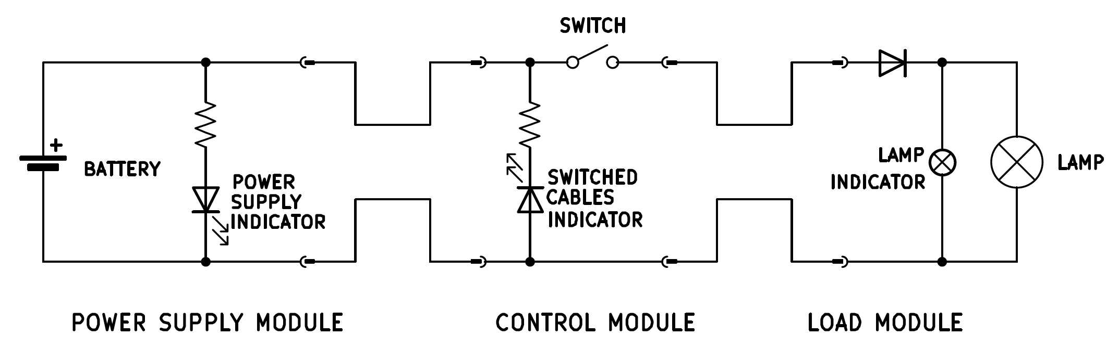

The system has the overall function of operating a load (lightbulb).

The system is composed of three modules connected in series: a power supply module, a control module, a load module.
Each module is made of an electrical circuit encased in a wooden cube of 10cm.
The modules are connected by unmarked cables: two cables come out of one face of the power supply cube and of the load cube, four cables come out of two opposite faces of the control module cube (two cables per face).
The cables are unmarked and have the same color: one cannot distinguish one from the other just by looking at them.
The cable terminates with fast-connection terminals that can be attached and detached together, allowing for connecting and disconnecting the modules together, and switching the cables polarity of two connected modules.
The bottom face of each cube is open, so lifting the cube up, and turning it upside down allows one to look at the circuit inside.

On the face of the power supply module cube opposite to the cables exit, there is a female cylindrical socket for a 12V input. The source of the 12V input can be either a wall wart or a battery in a battery case, by means of an appropriate male plug. On the top face there is a green LED. The LED is in series with a resistor, and the LED and the resistor are in parallel to the source, and the LED is oriented so that it will turn on when the 12V source is connected. Of the cables that exit the module, one is connected to the 12V input positive port, the other to the negative port.

The four cables coming out of the control cube constitute two connected pairs (so during operations one cable per face will carry 12V, the other 0V). Internally, each input cable is connected to the corresponding output cable, except for one line, which is interrupted by a switch mounted on the cube face. Connected in between the 12V line and the 0V line there is another resistor in series with a red led, encased on the top face of the cube that will turn on if the 12V line is mistakenly swapped with the 0V line from the power supply during installation. This LED is sometimes called control module indicator or control module LED but is generally called inverted cables indicator.

The two cables coming out of the load module are connected to the load terminals. The lightbulb itself is encased on the top face of the cube. In parallel to the lightbulb there is a smaller indicator lightbulb, that is positioned inside the cube, and can be seen only by either lifting the cube or (preferably) by opening a small peephole located on one of the cube faces. Both lightbulbs are not polarized by themselves, however there is a diode located on the 12V line, before both lightbulbs, such that it will allow current to flow only if the 12V and 0V lines are actually energized with 12V and 0V respectively (it will block current if the polarity is switched).

